**Title**

Insert author(s) name here

Insert affiliation and address here

E-mail address here

as follow

Tsubaki Camellia1* and Wabisuke Camellia2

1Horticultural Laboratory, Camellia University, XXX City, Postal code, Country;

2Camellia Botanical Garden, XXX City, Postal code, Country

*tsubaki.camellia@cmail.com

**Keywords**: List up to 5 keywords in alphabetical order (ex. biological control, fungi. . .)

**Abstract**

The Abstract should clearly express the basic content of the paper. Abstracts must not exceed 250 words.

**INTRODUCTION**

Please state the background of your study, the problem addressed, experimental approach, etc. in this section.

**MATERIALS AND METHODS**

Please state the plant material (species name, cultivar name, and number of their plants) and the methods, etc. in this section.

**RESULTS AND DISCUSSION**

Please state the main results and findings, conclusions, etc. in this section.

**LITERATURE CITED**

Scott, M.A. 1977. Methods of improving flower bud initiation in camellias. Expt. Hort. 29:80‐93.

San-Jośe, M.C. and Vieitez, A.M., 1990. *In vitro* regeneration of *Camellia reticulata* cv. ‘Captain Rawes’ from adult material. Scientia Hort. 43:155‐162.

Savige, T.J. 1994. The International Camellia Register. International Camellia Society, Wirlinga, Australia

Daubeny, H.A. 1996. Brambles. p.109‐190. In: J. Janick and J.N. Moore (eds.), Fruit Breeding, Vol. 3, Nuts. Wiley, New York.

Wang, Z., Lifang, X., Baojung, F., Shiuchi, T. and Chunmei, X. 2012. Chuxiong Camellia, its discovery, history and present development. Proc. International Camellia Congress. Chuxiong, China 5-9 Feb. p. 1‐10.

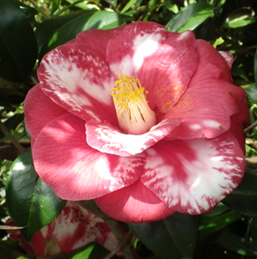

Fig. 1. Variegated flower of ‘Masayoshi’.

Table 1. *Camellia* cultivars and their flower colors

|  |  |  |
| --- | --- | --- |
| Species | Cultivar | Flower color |
| *Camellia japonica* | Masayoshi | Bicolor (Red and white) |
|  | Tamanoura | Bicolor (Red and white) |
| *Camellia sasanqua* | Waka-no-ura | White |
|  | Onishiki | Bicolor (Red and white) |

* Please adjust the placement of figures and tables in the manuscript as necessary.